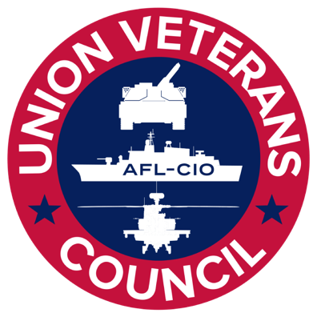

Pass the PRO Act to Protect Veteran Workers

Talking Points: A Union Gives a Veteran a Better Life

Military Families are Union Families

Veterans and military families have a long history of being a part of unions, and many more veterans will join unions if they are given the opportunity.

- Over one million veteran workers are union members.

- Unions offer veterans the same sense of community that the military does.

- Veterans are one third more likely to join a union than nonveterans.

- Due to anti-union laws many veterans have not even had the opportunity to join a union.

- Research from the Massachusetts Institute of Technology shows nearly 60 million people (almost half of nonunion workers) would vote to join a union today if given the opportunity.

- Passing the PRO Act will create a pathway for even more veterans to become union veterans and allow them to live the American dream they served to defend

Veterans Need Unions

Transitioning from military service is difficult, and unions help veterans navigate that difficult transition and set themselves up for success long-term with good careers.

- Financial instability is one of the greatest challenges facing veterans and transitioning service members. Fair wages and stable jobs will help us end the epidemic of veteran suicide.

- Despite our obligation to make sure our veterans are financially stable, 31% of all working veterans make less than $31k per year.

- 39% of veterans working in the construction industry make less than $20 an hour, many with no to few benefits.

- 1 out of every 5 working veterans would benefit from raising the federal minimum wage to $15 an hour by 2024.

- Unions are one of the best paths to achieving higher wages. When union membership is greater, veterans and military families do better.

- Between 1948 and 1973, when New Deal era laws expanded and enforced collective bargaining, hourly wages rose by more than 90%. Millions of WWII GI’s returned home and used a union job to help drive the creation of the middle class following the war. But over the next 40 years—from 1973 to 2013—hourly wages rose by just over 9% while productivity increased 74%.

- In the military, we all serve on equal footing, regardless of our backgrounds, race, gender, or sexual orientation or identity. But when we return, veterans of color, female veterans, and LGBTQ veterans face unique challenges.

- Just like the military, unions create an equal playing field for veteran workers, no matter your gender, sexual orientation or identity, or the color of your skin.

- Collective bargaining increases protections for women, people of color, immigrants and the LGBTQ community in areas where our laws are still falling short.

- A union contract is the single best tool we have to close racial and gender wage gaps in the veteran workforce, and to ensure dignity and due process for workers, regardless of where we were born, who we are, or what industry we work in.

- Of the 20 million veterans in the U.S., only 6.1 million veterans receive their healthcare through the Department of Veterans Affairs. Unions help veterans access quality, affordable healthcare through their employers and/or their unions.

Veteran Workers Need the PRO Act

The PRO Act will enact changes to make it easier to collectively bargain and win key victories that will improve the lives of veteran workers and their families across the country.

- The PRO act will give veterans and workers the freedom to band together and collectively have a say in their own economic future and working conditions.

- The PRO Act creates pathways for workers to form unions, without fear, in newer industries like Big Tech and further empowers workers to exercise our freedoms to organize and bargain.

- Under the PRO Act, more gig workers could be classified as employees entitled to NLRA protections. Many veterans in need of healthcare and higher wages are finding employment through gig jobs, and would benefit from being able to organize and/or join a union.

- The PRO Act ensures that workers can reach a first contract quickly after a union is recognized -- stopping employers from delaying the process so that workers never realize their hard-fought gains.

- Further, the PRO Act puts an end to an employers’ practice of punishing striking workers by hiring permanent replacements. Speaking up for labor rights is within every worker’s rights—and workers shouldn’t lose our jobs for it.

- The PRO Act will hold corporations accountable by strengthening the National Labor Relations Board and allowing it to penalize employers who retaliate against working people in support of the union or collective bargaining.

- The PRO Act will repeal “right to work” laws—divisive and racist laws created during the Jim Crow era—that lead to lower wages, fewer benefits, and more dangerous workplaces.

